Guidance for adding MyChart recruitment to your IRB application
- Fill out the Modification Form
- Revise the application

Note 1: The IRB has an interactive online tutorial about how to submit a modification at http://iris-help.ucsf.edu/irb-iris (requires MyAccess login).
Note 2: The screenshots below are from the 2017 version of the IRB application. The section titles and color scheme may look different for your study, depending on which version of the application you are using.
Note 3: If you already have IRB approval to use the CTSI Recruitment letter service, you do not need to include the highlighted guidance text.

1. Modification Form:

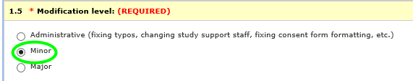
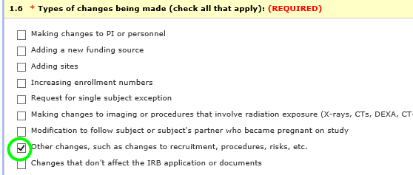

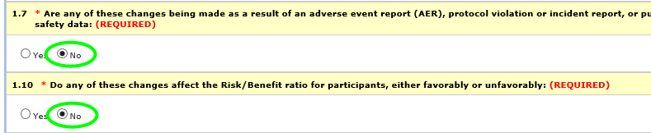
- In the above section, add the following wording:

This study is working with CTSI to use MyChart for recruitment along with cohort identification and direct mail for recruitment of patients who are not enrolled in MyChart. Here’s how it works:
MyChart (Apex) conducts a search for patients based on the study’s inclusion and exclusion criteria. This is a completely computer-aided search, meaning the computer — and not a person — searches patient charts. When a patient is identified as potentially eligible, they receive an email from MyChart that says to log in to MyChart to read about a study that they might be interested in. The email is short and is the same for every recipient—there is no patient-specific, study-specific or disease information in it.
When the patient logs into MyChart, there is a “Research” page with template information about participating in research and how to opt out of receiving recruitment messages. The patient can click through to learn about a specific study that they may be eligible for. This study-specific language is attached to this submission.
Of note:
1. The patient has the option of clicking a link/button to let the study team know that they are interested in learning more about the study. Only if the patient takes this action will the study team receive information about the patient. If the patient clicks “No thanks” or simply does not respond, they will not be contacted by the study team, they will not receive any follow-up emails from MyChart about this study, and their information will not be shared with the study team.
2. The messaging in all recruitment materials—email, MyChart research page, and study description—have been written to clearly state that the patient is being contacted about research, not clinical care.
We are collaborating with the CTSI Participant Recruitment Program (PRP), which will provide cohort identification and direct mail for recruitment of patients who are not enrolled in MyChart in order to address racial and ethnic disparities that exist in MyChart enrollment.

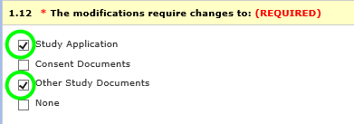

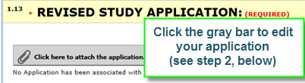
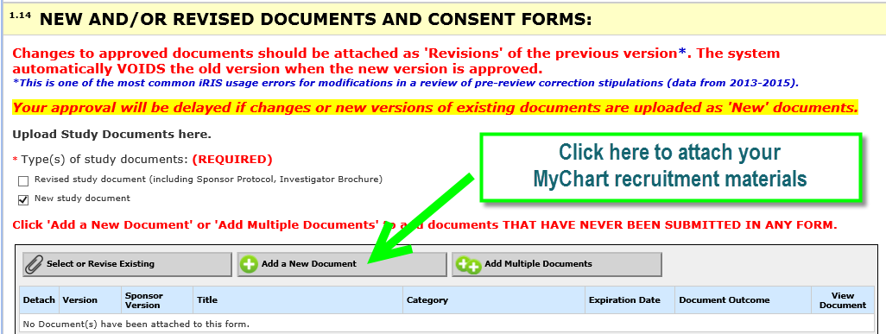

2. Application Form:
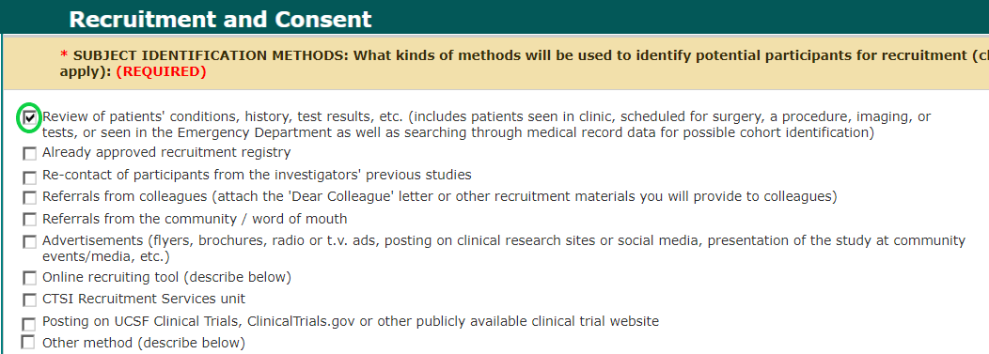

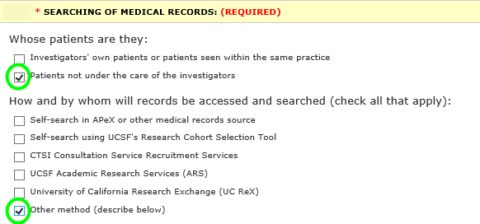
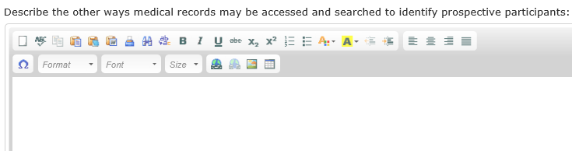
- In the above “Other” text box, add the following wording:
A computer-aided search will be performed by Apex. Details are below in the discussion of MyChart recruitment.

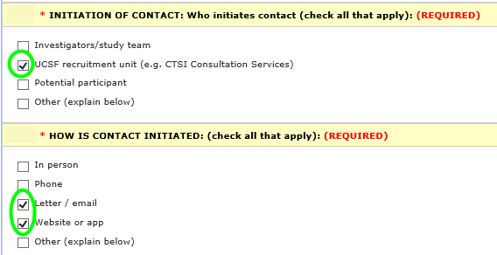
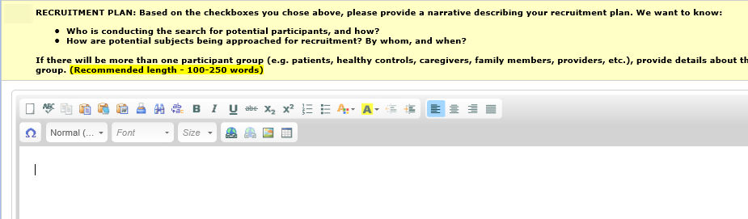
- In the “Recruitment Plan” section, add the following wording:

My Chart Recruitment:
MyChart (Apex) conducts a search for patients based on the study’s inclusion and exclusion criteria. This is a completely computer-aided search, meaning the computer—and not a person-- searches patient charts. When a patient is identified as potentially eligible, they receive an email from MyChart that says to log in to MyChart to read about a study they might be interested in. The email is short and is the same for every recipient—there is no patient-specific, study-specific or disease information in it.
When the patient logs into MyChart, there is a “Research” tab with template information about participating in research and how to opt out of receiving recruitment messages. The patient can click through to learn about a specific study they may be eligible for.
The patient has the option of clicking a link/button to let the study team know that they are interested in learning more about the study. Only if the patient takes this action will the study team receive information about the patient. If the patient clicks “No thanks” or simply does not respond, they will not be contacted by the study team, they won’t receive any follow-up emails from MyChart about this study, and their information will not be shared with the study team.
To address racial and ethnic disparities that exist in MyChart enrollment, we will also collaborate with the CTSI Participant Recruitment Program (PRP) to send paper letters to patients who are not enrolled in MyChart. CTSI PRP will act as an honest broker of the EHR data and sends letters to the cohort directly, ensuring privacy and confidentiality of patients identified. The data extract will be done using APeX reports and will be downloaded and stored in the CTSI PRP MyResearch account. The CTSI PRP will coordinate the mailing on behalf of the study and will send the Dear Patient letter (attached) to UCSF patients identified in these reports. Interested subjects will contact the study staff as described in the letter. Protected data elements included in the data pull may include MRN, name, mailing address, and diagnosis or encounter date.

