Creating Demographic Reports in EHRMa

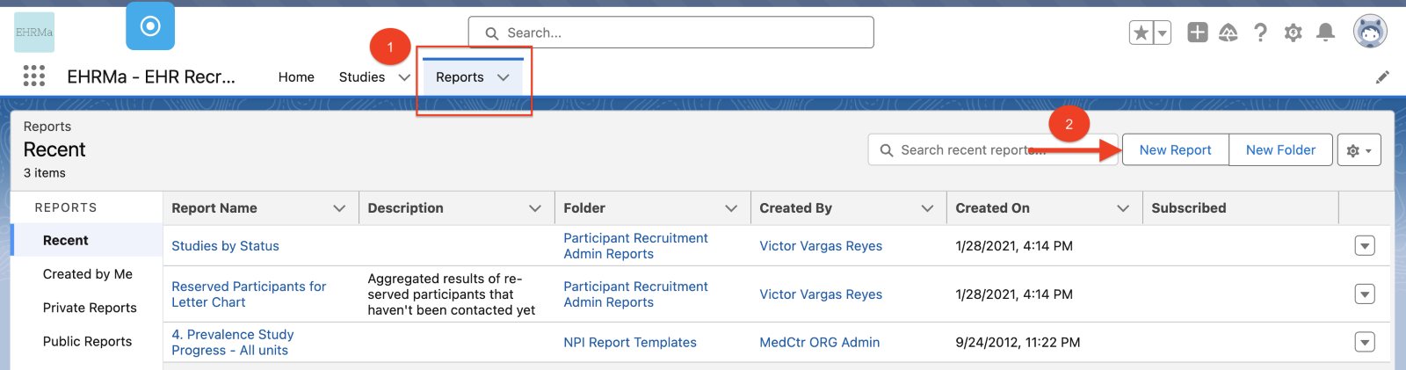

1. Login to EHRMa application -> Open Report tab.
2. Click on ‘New Report’ button to Create a Report.

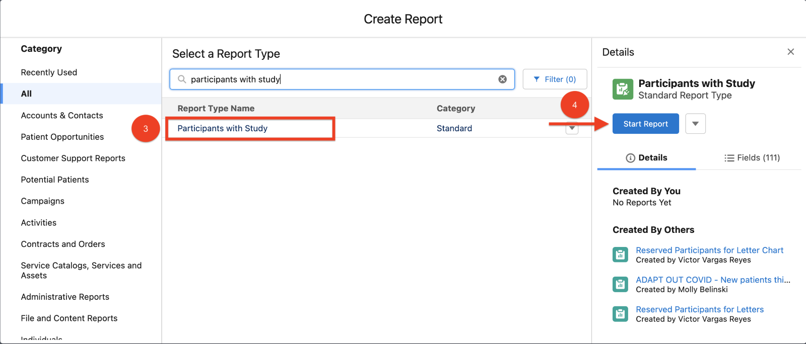
3. Select ‘Participant with Study’ report type.
4. Click ‘Start Report’ button.
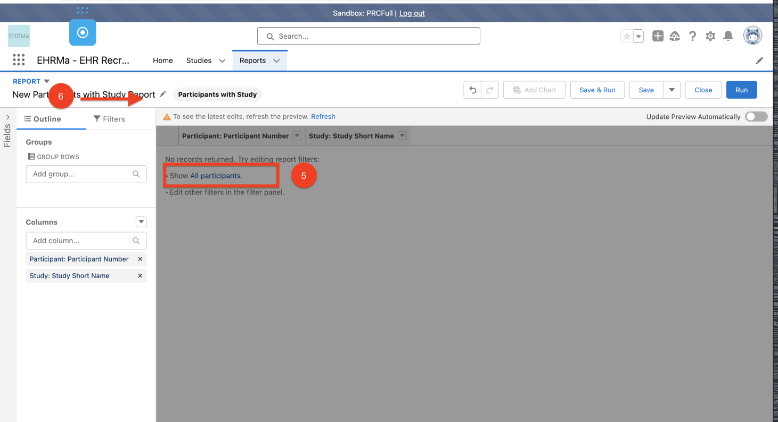
5. Click to Show All Participants.
6. Update the name of the report to a meaningful name.

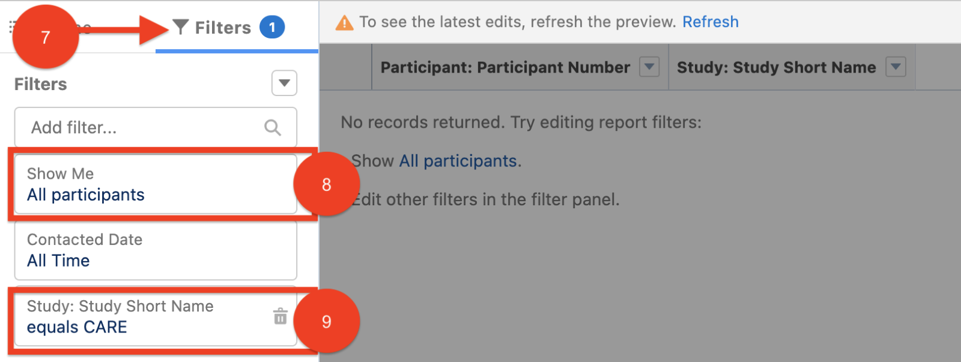
7. Navigate to ‘Filters’ tab.
8. Confirm ‘All participants’ filter is set.
9. If needed, apply a filter to display a specific study. For example: Study Short Name = CARE.
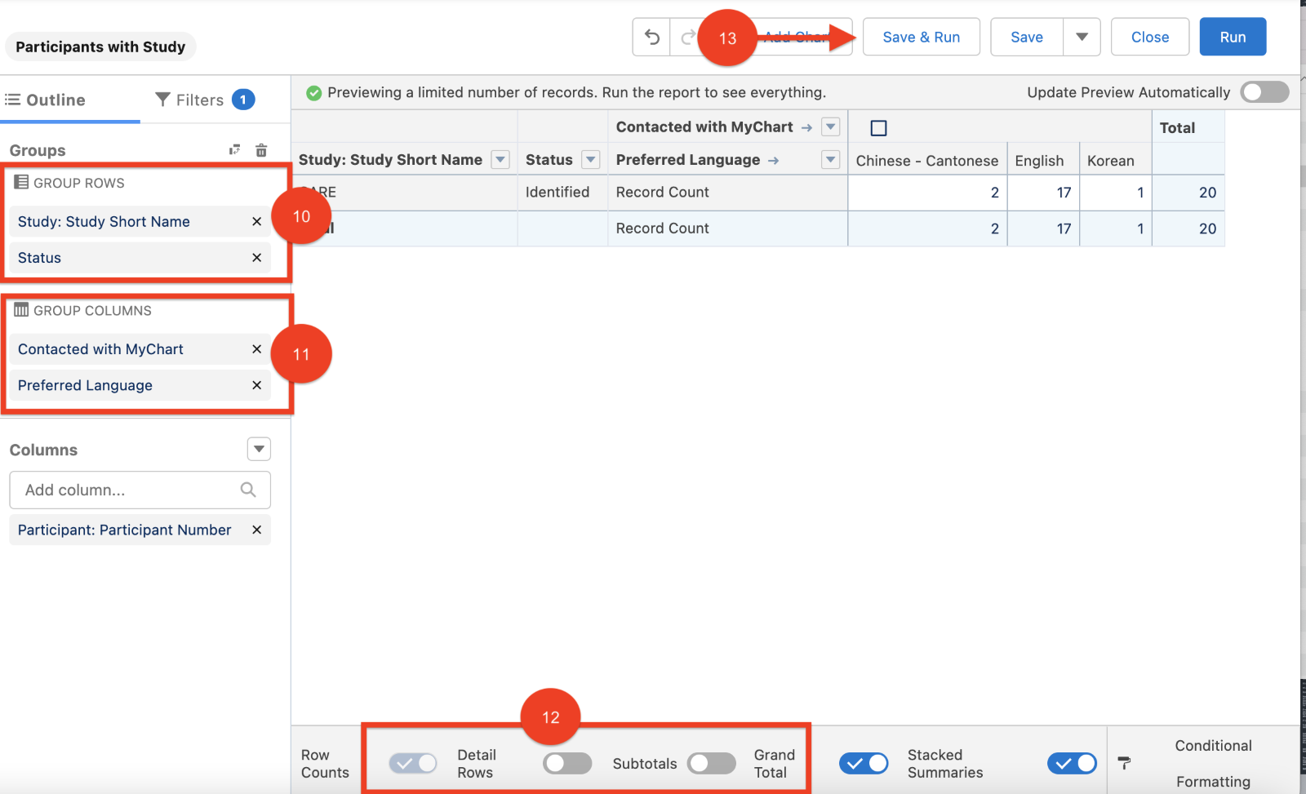
10. Open Outline Tab and add GROUP ROWS filters.
11. Select up to two GROUP COLUMS filters. NOTE: all dashboard variables are available for reporting, for example, Preferred Language, gender, ethnicity, race, city, etc.
12. Configure report display options.
13. Click ‘Save & Run’ to generate a report.

