EHR Participant Recruitment

This document demonstrates the workflow for using the CTSI Participant Recruitment Program’s EHR Recruitment Service, and applies only to studies that have completed the [EHR Recruitment set-up](https://recruit.ucsf.edu/mychart-recruitment-service-information-portal) process with the CTSI Participant Recruitment Program (PRP).

**To use the CTSI EHR Recruitment Service, studies will need to use two systems:**

* Use **EHRMa** (**EHR** **R**ecruitment **Ma**nager) to send messages and view metrics. Your account will be created for you by the Participant Recruitment Program as part of the set-up process; sign-in is via MyAccess.
* Use APeX InBasket messaging system to view responses from interested patients. Study team members are responsible for creating their own APeX accounts; once the accounts are confirmed, PRP will add study team members to the research settings in APeX so they can receive responses.

# Send Messages and View Metrics (via EHRMa)

1. Log into EHRMa using MyAccess: <https://medctr-ucsf.lightning.force.com>
2. In the top horizontal Menu, click “Studies” and then select the study for which you would like to recruit. You will only see studies that you are part of that are set up for the EHR Recruitment Service. **Note: you may need to select the drop down arrow next to “Recently Viewed” to view “All” studies.**

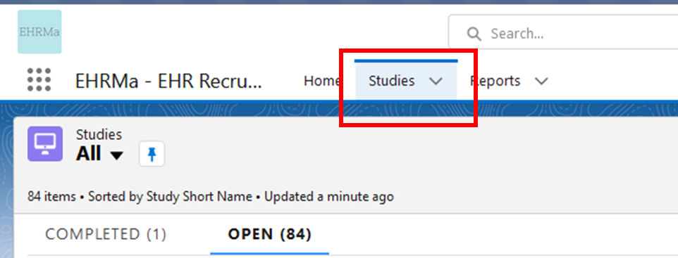

1. Once you’ve selected your study, you will land on the EHRMa Dashboard. An overview of the EHRMa dashboard features is on the next page.

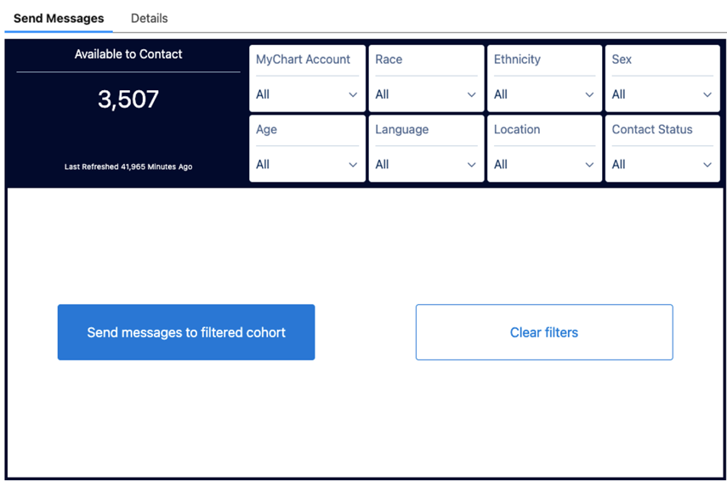**EHRMa Dashboard**

**Demographic Dashboard Features**

**1: Selecting Demographic Filters**

Choose demographic filters that match your target audience. Options include MyChart account status, race, ethnicity, sex, age, language, and location by zip code. Click on each filter to apply your criteria, and the filtered cohort count will be updated on the dashboard.

* All filters are optional.
* Your unfiltered cohort represents the results of your query that you set up with the programming team.
* To review your applied filters before sending recruitment messages, hover over the "Show Applied Filters" hyperlink for a quick glance at your criteria.

**2. Send Messages**

Any filters applied in step 1 will update the results of the “available patients” in the “Send Messages” section.

* You can send up to 250 messages per day to MyChart users.
* There is no limit to the number of letters you can send at once. You can use EHRMa to initiate letters at any time; however PRP will process letters bimonthly. Visit the [Recruitment Letters Information](https://recruit.ucsf.edu/mychart-recruitment-service-information-portal#EHR-Recruitment-Letters-Information) section of the PRP website to learn more about prices and mailing schedule.

**3. Exclude Patients from Recruitment using MRN**

Use this button to add a list of MRNs of patients that you want to exclude from your recruitment contact. (For example, patients whom you have already screened and do not qualify for your study.) You only need to do this step once and they will be excluded from your list in the future.

**4. Recruitment Metrics**

View EHRMa recruitment activity in this section, including: total number of eligible patients identified through your query; MyChart account status of your cohort, and response data.

*Note: The accompanying video link demonstrations this process in detail.*

<https://youtu.be/yX2hdjrmRlw>

4







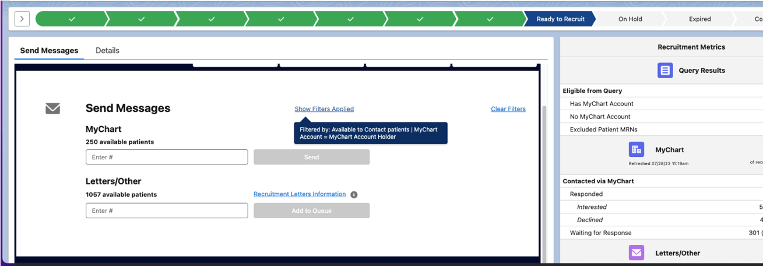

*****EHRMa Dashboard**

**Explore Patient Demographics**

1. **Explore Patient Demographics**: Utilize the "Explore Patient Demographics" section to see the results of the filters for race, ethnicity, age, sex, language, zip code, and contact status.

**Tip**: You can analyze patient cohorts based on different contact statuses like "Available to contact," "Contacted via letters," or "Waiting for response" to gain insights into engagement levels.

2. **Compare All Eligible:** Use the "Compare All Eligible" button to compare your filtered cohort to all eligible patients identified for your study, providing a comprehensive understanding of your recruitment efforts.

*Note: The accompanying video link demonstrations this each process in detail.*

<https://www.youtube.com/watch?v=yX2hdjrmRlw>

**Recruitment Letters**

PRP ***requires*** including paper letters in outreach efforts to ensure equitable participation in research. We recommend that 10% of your EHR Recruitment outreach be by paper letter. Please visit our [**MyChart Activation Rates and Equitable Outreach**](https://recruit.ucsf.edu/mychart-recruitment-service-information-portal#MyChart-Activation-and-Equitable-Recruitment-Outreach)page to read more about MyChart activation rates and why we require studies to send letters in addition to MyChart messages.

**Sending out recruitment letters**

**EHRMa Dashboard**

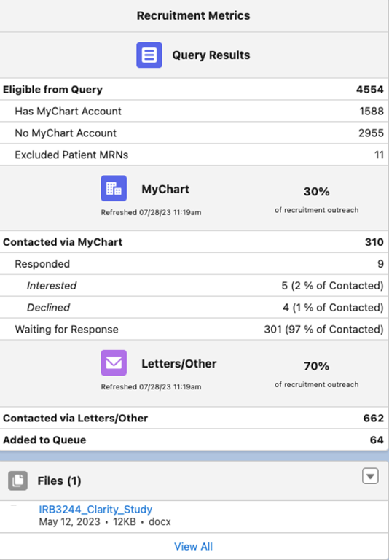

**1. Update Letter Templates:**

Ensure your study's recruitment letters are up to date by visiting the "Files" section on the lower right-hand side of the platform. Review and update your letter templates as needed.

**2. Mailing Schedule and Discounted Postage:**

PRP staff processes mailings twice a month, with letters reaching their destination approximately two weeks after processing. For orders over 200 pieces, you'll qualify for a discounted non-profit postage rate. Check the "[Recruitment Letters Information](https://recruit.ucsf.edu/mychart-recruitment-service-information-portal#MyChart-Activation-and-Equitable-Recruitment-Outreach)" link on the main page for more details.

**3. Multiple Languages:**

When using different templates for letters in multiple languages, contact PRP@ucsf.edu to confirm which templates to use.

*Note: The accompanying video link demonstrations this process in detail.*

<https://youtu.be/IEbh9b4QUU4>

4



# View Recruitment Responses and Follow up

When the patient selects “I’m interested” or “No, Thank you” the status of the Research Study is updated respectively. If a patient clicks “I’m interested”, the patient’s response is returned to study personnel via an APeX InBasket message.

1. Log into ApeX, select the In Basket workspace.



1. Select the message, the message details appear to the right.

• The patient’s decision is noted in the Research Recruitment section.



1. Once a patient indicates “I’m Interested”, the study team can respond to the patient as best fits their study workflow.



NOTE: Inbasket messages are not shared with other team members. Messages sent to you, must be managed by you.